HOSPITAL SCHEMA

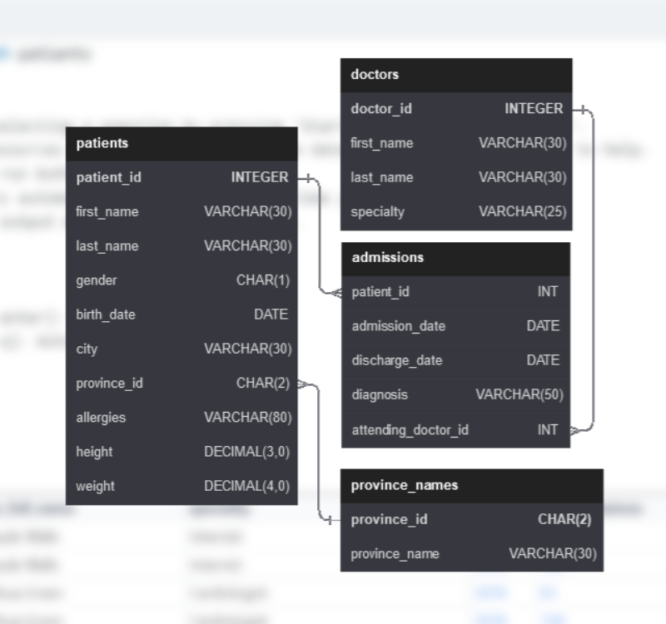

EASY Questions:

1. **Show first name, last name, and gender of patients whose gender is 'M':**

* SELECT first_name, last_name, gender

FROM patients

where gender='M';

1. **Show first name and last name of patients who does not have allergies. (null)**

* SELECT first_name, last_name

FROM patients

where allergies IS NULL;

1. **Show first name of patients that start with the letter 'C'**

* SELECT first_name

FROM patients

where first_name LIKE 'C%';

1. **Show first name and last name of patients that weight within the range of 100 to 120 (inclusive)**

* SELECT first_name, last_name

FROM patients

where weight between 100 AND 120;

1. **Update the patients table for the allergies column. If the patient's allergies is null then replace it with 'NKA'**

* update patients

set allergies='NKA'

where allergies IS NULL;

1. **Show first name and last name concatinated into one column to show their full name.**

* select concat(first_name,' ',last_name) AS full_name from patients;

1. **Show first name, last name, and the full province name of each patient.  
     
   Example: 'Ontario' instead of 'ON'**

* select p.first_name,p.last_name,pr.province_name

from patients p inner join province_names pr

on p.province_id=pr.province_id;

1. **Show how many patients have a birth_date with 2010 as the birth year.**

* select count(*)

from patients

where year(birth_date) = 2010;

1. **Show the first_name, last_name, and height of the patient with the greatest height.**

* select first_name,last_name, MAX(height)

from patients;

1. **Show all columns for patients who have one of the following patient_ids:**1,45,534,879,1000

* select *

from patients

where patient_id IN (1,45,534,879,1000);

1. **Show the total number of admissions**

* select COUNT(*)

from admissions;

1. **Show all the columns from admissions where the patient was admitted and discharged on the same day.**

* select *

from admissions

where admission_date=discharge_date;

1. **Show the patient id and the total number of admissions for patient_id 579.**

* select patient_id, count(patient_id)

from admissions

where patient_id=579;

1. **Based on the cities that our patients live in, show unique cities that are in province_id 'NS'?**

* select distinct(city) as unique_cities

from patients

where province_id='NS';

1. **Write a query to find the first_name, last name and birth date of patients who has height greater than 160 and weight greater than 70**

* select first_name,last_name, birth_date

from patients

where height>160 and weight>70;

1. **Write a query to find list of patients first_name, last_name, and allergies where allergies are not null and are from the city of 'Hamilton'**

* select first_name,last_name, allergies

from patients

where allergies IS NOT NULL and city='Hamilton';

MEDIUM Questions:

1. **Show unique birth years from patients and order them by ascending.**

* select distinct year(birth_date)

from patients

order by year(birth_date) asc;

1. **Show unique first names from the patients table which only occurs once in the list.  
     
   For example, if two or more people are named 'John' in the first_name column then don't include their name in the output list. If only 1 person is named 'Leo' then include them in the output.**

* select distinct first_name

from patients

group by first_name

having count(first_name)=1;

1. **Show patient_id and first_name from patients where their first_name start and ends with 's' and is at least 6 characters long.**

* select patient_id, first_name

from patients

where len(first_name)>=6 and first_name like 's%s';

1. **Show patient_id, first_name, last_name from patients whos diagnosis is 'Dementia'.  
   Primary diagnosis is stored in the admissions table.**

* select p.patient_id, p.first_name, p.last_name

from patients p inner join admissions a

on p.patient_id= a.patient_id

where a.diagnosis='Dementia';

1. **Display every patient's first_name.  
   Order the list by the length of each name and then by alphabetically.**

* select first_name

from patients

order by len(first_name), first_name asc;

1. **Show the total amount of male patients and the total amount of female patients in the patients table.  
   Display the two results in the same row.**

* select

(select count(patient_id) from patients where gender='M')as male_count,

(select count(patient_id) from patients where gender='F')as female_count;

1. **Show first and last name, allergies from patients which have allergies to either 'Penicillin' or 'Morphine'. Show results ordered ascending by allergies then by first_name then by last_name.**

* select first_name, last_name, allergies

from patients

where allergies IN ('Penicillin','Morphine')

order by allergies,first_name,last_name ASC;

1. **Show patient_id, diagnosis from admissions. Find patients admitted multiple times for the same diagnosis.**

* select patient_id, diagnosis

from admissions

group by patient_id,diagnosis

having count(diagnosis)>1;

1. **Show the city and the total number of patients in the city.  
   Order from most to least patients and then by city name ascending.**

* select city, count(patient_id) AS no_of_patients

from patients

group by city

order by no_of_patients desc,city asc;

1. **Show first name, last name and role of every person that is either patient or doctor.  
   The roles are either "Patient" or "Doctor"**

* select first_name, last_name, 'Patient' as role from patients

union all

select first_name, last_name, 'Doctor' as role from doctors;

1. **Show all allergies ordered by popularity. Remove NULL values from query.**

* select allergies, count(allergies) as total_diagnosis

from patients

where allergies IS NOT null

group by allergies

order by total_diagnosis desc;

1. **Show all patient's first_name, last_name, and birth_date who were born in the 1970s decade. Sort the list starting from the earliest birth_date.**

* select first_name, last_name, birth_date

from patients

where year(birth_date) between 1970 and 1979

order by birth_date asc;

1. **We want to display each patient's full name in a single column. Their last_name in all upper letters must appear first, then first_name in all lower case letters. Separate the last_name and first_name with a comma. Order the list by the first_name in decending order  
   EX: SMITH,jane**

* select concat(upper(last_name),',',lower (first_name)) as full_name

from patients

order by first_name desc;

1. **Show the province_id(s), sum of height; where the total sum of its patient's height is greater than or equal to 7,000.**

* select province_id, SUM(height) as total_height

from patients

group by province_id

having total_height >=7000;

1. **Show the difference between the largest weight and smallest weight for patients with the last name 'Maroni'**

* select MAX(weight)-min(weight) as diff

from patients

where last_name ='Maroni';

1. **Show all of the days of the month (1-31) and how many admission_dates occurred on that day. Sort by the day with most admissions to least admissions.**

* select Day(admission_date) as days, count(day(admission_date)) as admissions

from admissions

group by day(admission_date)

order by admissions desc;

1. **Show all columns for patient_id 542's most recent admission_date.**

* select *

from admissions

where patient_id=542 and admission_date IN (

select admission_date from admissions

where patient_id=542

order by admission_date desc

limit 1);

1. **Show patient_id, attending_doctor_id, and diagnosis for admissions that match one of the two criteria:  
   1. patient_id is an odd number and attending_doctor_id is either 1, 5, or 19.  
   2. attending_doctor_id contains a 2 and the length of patient_id is 3 characters.**

* select patient_id, attending_doctor_id, diagnosis

from admissions

where (patient_id%2=1 and attending_doctor_id IN (1,5,19))

or (len(patient_id)=3 and attending_doctor_id LIKE ('%2%'));

1. **Show first_name, last_name, and the total number of admissions attended for each doctor.  
   Every admission has been attended by a doctor.**

* select d.first_name, d.last_name, count(a.attending_doctor_id)

from doctors d inner join admissions a

on d.doctor_id=a.attending_doctor_id

group by doctor_id;

1. **For each doctor, display their id, full name, and the first and last admission date they attended.**

* select d.doctor_id, concat(d.first_name,' ',d.last_name) AS full_name,

min(a.admission_date) as first_admission_date,

max(a.admission_date) AS last_admission_date

from doctors d inner join admissions a

on d.doctor_id=a.attending_doctor_id

group by doctor_id;

1. **Display the total amount of patients for each province. Order by descending.**

* select p.province_name, COUNT(pa.patient_id) as amt_of_patients

from patients pa inner join province_names p

on pa.province_id=p.province_id

group by pa.province_id

order by amt_of_patients DESC;

1. **For every admission, display the patient's full name, their admission diagnosis, and their doctor's full name who diagnosed their problem.**

* select concat(p.first_name,' ',p.last_name) as patient_full_name,

a.diagnosis,

concat(d.first_name,' ',d.last_name) as doctor_name

from patients p inner join admissions a

on p.patient_id=a.patient_id

inner join doctors d

on a.attending_doctor_id=d.doctor_id;

1. **display the first name, last name and number of duplicate patients based on their first name and last name.  
   Ex: A patient with an identical name can be considered a duplicate.**

* select first_name,last_name, count(concat(first_name,' ', last_name)) as duplicates

from patients

group by concat(first_name,' ', last_name)

having duplicates>1;

1. **Display patient's full name,  
   height in the units feet rounded to 1 decimal,  
   weight in the unit pounds rounded to 0 decimals,  
   birth_date,  
   gender non abbreviated.  
     
   Convert CM to feet by dividing by 30.48.  
   Convert KG to pounds by multiplying by 2.205.**

* select concat(first_name,' ', last_name) as full_name,

round(height/30.48,1) as height_in_feet,

round(weight*2.205) as weight_in_pounds,

birth_date,

(case

when gender='M' then 'Male'

Else 'Female'

END) AS patient_gender

from patients;

1. **Show patient_id, first_name, last_name from patients whose does not have any records in the admissions table. (Their patient_id does not exist in any admissions.patient_id rows.)**

* select patient_id,first_name,last_name

from patients

where patient_id not in (select patient_id from admissions);

HARD Questions:

1. **Show all of the patients grouped into weight groups.  
   Show the total amount of patients in each weight group.  
   Order the list by the weight group decending.  
     
   For example, if they weight 100 to 109 they are placed in the 100 weight group, 110-119 = 110 weight group, etc.**

* select count(patient_id) as no_of_patients,

floor(weight/10) * 10 as weight_group

from patients

group by weight_group

order by weight_group DESC;

1. **Show patient_id, weight, height, isObese from the patients table.  
   Display isObese as a boolean 0 or 1.  
     
   Obese is defined as weight(kg)/(height(m)2) >= 30.  
   weight is in units kg.  
   height is in units cm.**

* select patient_id,

weight,

height,

(case

when (weight/power(height/100.0,2)) >= 30 then 1

ELSE 0

END) AS isObese

from patients;

1. **Show patient_id, first_name, last_name, and attending doctor's specialty.  
   Show only the patients who has a diagnosis as 'Epilepsy' and the doctor's first name is 'Lisa'  
     
   Check patients, admissions, and doctors tables for required information.**

* select p.patient_id, p.first_name, p.last_name,

d.specialty

from patients p inner join admissions a

on p.patient_id=a.patient_id

inner join doctors d

on a.attending_doctor_id=d.doctor_id

where a.diagnosis= 'Epilepsy' and d.first_name='Lisa';

1. **All patients who have gone through admissions, can see their medical documents on our site. Those patients are given a temporary password after their first admission. Show the patient_id and temp_password.  
   The password must be the following, in order:**

**1. patient_id  
2. the numerical length of patient's last_name  
3. year of patient's birth_date**

* select distinct p.patient_id,

concat(a.patient_id,len(p.last_name),year(p.birth_date)) as temp_password

from patients p inner join admissions a

on p.patient_id=a.patient_id;

1. **Each admission costs $50 for patients without insurance, and $10 for patients with insurance. All patients with an even patient_id have insurance.  
     
   Give each patient a 'Yes' if they have insurance, and a 'No' if they don't have insurance. Add up the admission_total cost for each has_insurance group.**

* with total_cost as

(select patient_id,

(case

when patient_id%2=0 then 'Yes'

else 'No'

end) as has_insurance

from admissions),

admission_cost as

(select has_insurance,

(case

when has_insurance= 'Yes' then 10

else 50

end) as cost

from total_cost)

select has_insurance,SUM(cost) as cost_after_insurance

from admission_cost

group by has_insurance;

1. **Show the provinces that has more patients identified as 'M' than 'F'. Must only show full province_name:**

* SELECT pr.province_name

FROM patients pa JOIN province_names pr

ON pa.province_id = pr.province_id

GROUP BY pr.province_name

HAVING SUM(gender = 'M') > SUM(gender = 'F');

OR

* with gender_count as

(

select province_id,

sum(case

when gender='M' then 1

else 0

END) as male_count,

sum(case

when gender='F' then 1

else 0

END) as female_count

from patients

group by province_id)

select pr.province_name

from gender_count gc inner join province_names pr

on gc.province_id=pr.province_id

where gc.male_count>gc.female_count;

1. **We are looking for a specific patient. Pull all columns for the patient who matches the following criteria:  
   - First_name contains an 'r' after the first two letters.  
   - Identifies their gender as 'F'  
   - Born in February, May, or December  
   - Their weight would be between 60kg and 80kg  
   - Their patient_id is an odd number  
   - They are from the city 'Kingston'**

* SELECT *

from patients

where first_name like '__r%'

and gender='F'

and month(birth_date) IN (2,5,12)

and weight between 60 and 80

and patient_id%2=1

and city='Kingston';

1. **Show the percent of patients that have 'M' as their gender. Round the answer to the nearest hundreth number and in percent form.**

* select

CONCAT(ROUND(sum(gender='M')/cast(count(*) as float),4)*100,'%') as percent

from patients;

OR

* SELECT concat(round(sum(gender='M')/cast(Count(*) as float) *100,2),'%')as per

from patients;

1. **For each day display the total amount of admissions on that day. Display the amount changed from the previous date.**

* select admission_date,

count(patient_id) as tot_amt,

count(patient_id) - LAG(Count(patient_id)) OVER (order by admission_date ASC) AS amt_changed

from admissions

group by admission_date;

1. **Sort the province names in ascending order in such a way that the province 'Ontario' is always on top.**

* select province_name

from province_names

order by (case

when province_name='Ontario' then '1'

else '2'

end) asc;

OR

* select province_name

from province_names

order by

(not province_name = 'Ontario'),

province_name ASC;

OR

* select province_name

from province_names

order by province_name = 'Ontario' desc,

province_name;

1. **We need a breakdown for the total amount of admissions each doctor has started each year. Show the doctor_id, doctor_full_name, specialty, year, total_admissions for that year.**

* select d.doctor_id,

concat(d.first_name,' ',d.last_name) as doc_full_name,

d.specialty,

year(a.admission_date) as year,

count(a.patient_id) as tot_admissions

from admissions a inner join doctors d

on a.attending_doctor_id=d.doctor_id

group by year(a.admission_date),d.doctor_id

order by d.doctor_id,year(a.admission_date) desc;